<https://scikit-learn.ru/6-3-preprocessing-data/>

permut import fig 1

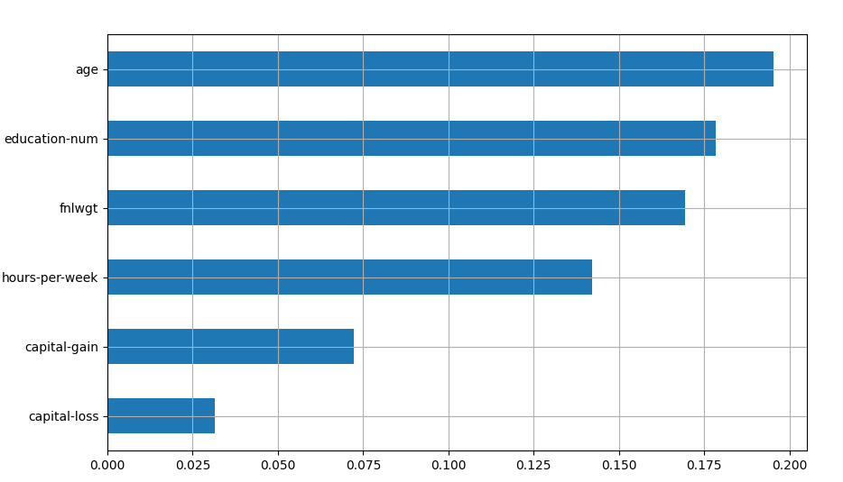

Permut imp fig 2

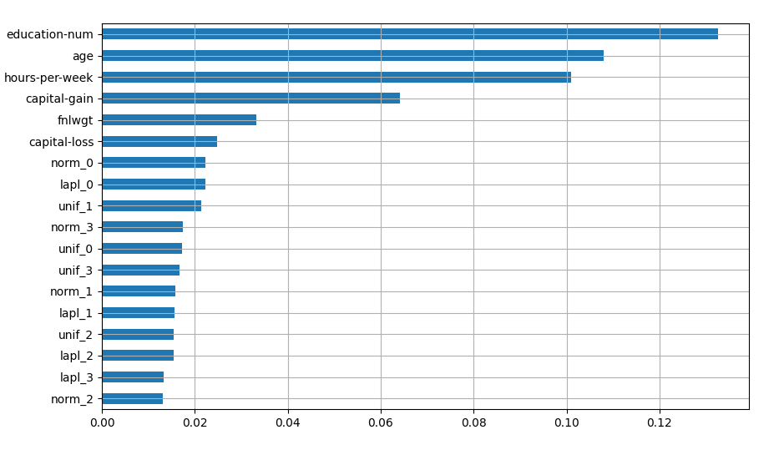

Perm import fig 3

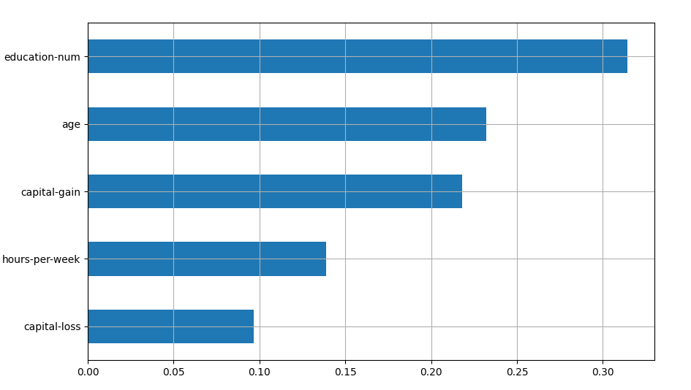

Surrogate random forest fig 1: real

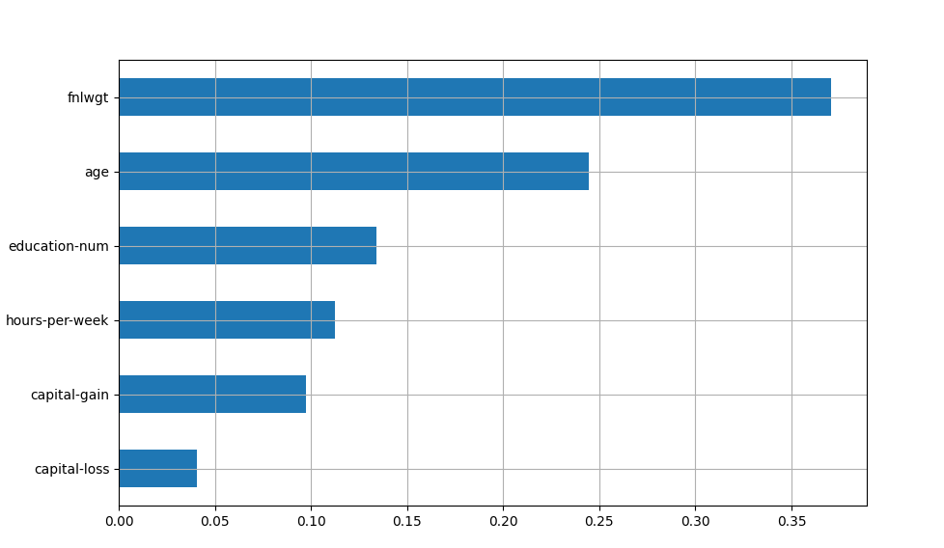

surrogate

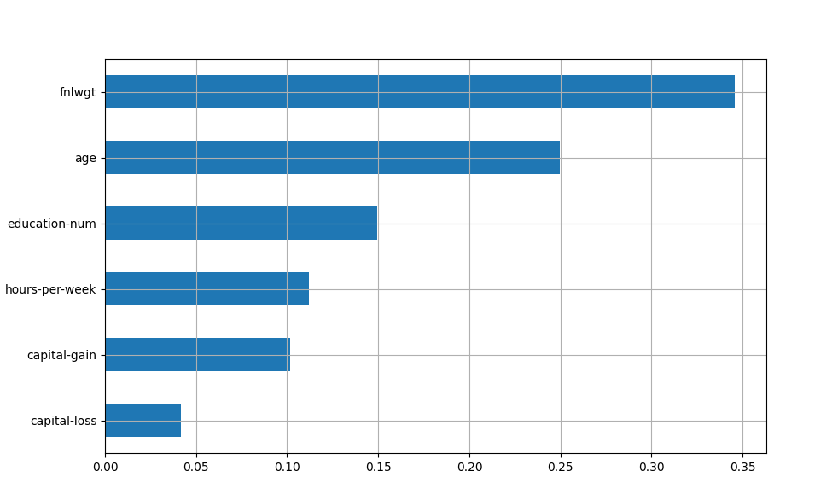

train scores = [0.99997586 0.99998316 0.9999789 0.99997561 0.99997187]

mean score = 0.99998 +/- 0.00000

test score = [0.86122731 0.86878913 0.87685501 0.86725615 0.86313271]

mean score = 0.86745 +/- 0.00543

Surrogate random forest fig 2: real

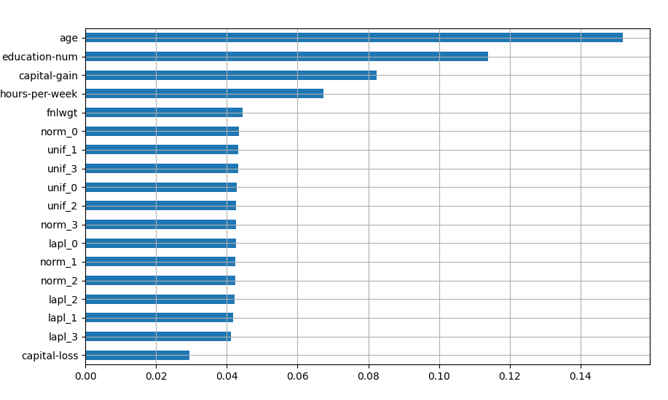

Surrogate:

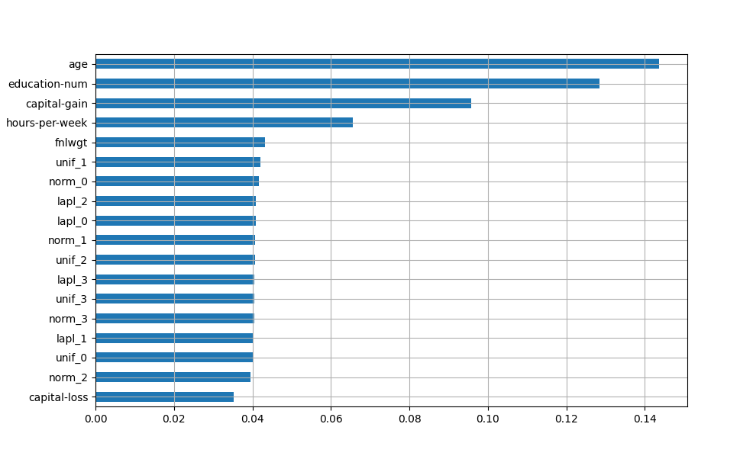

train scores = [1. 1. 1. 1. 1.]

mean score = 1.00000 +/- 0.00000

test score = [0.86590031 0.8665263 0.86342334 0.87133953 0.8588441]

mean score = 0.86521 +/- 0.00409

surrogate random forest fig 3: real

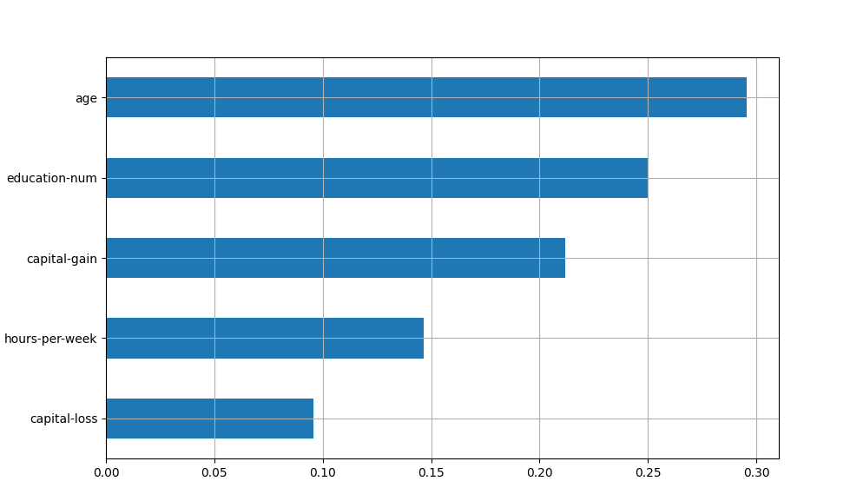

surrogate:

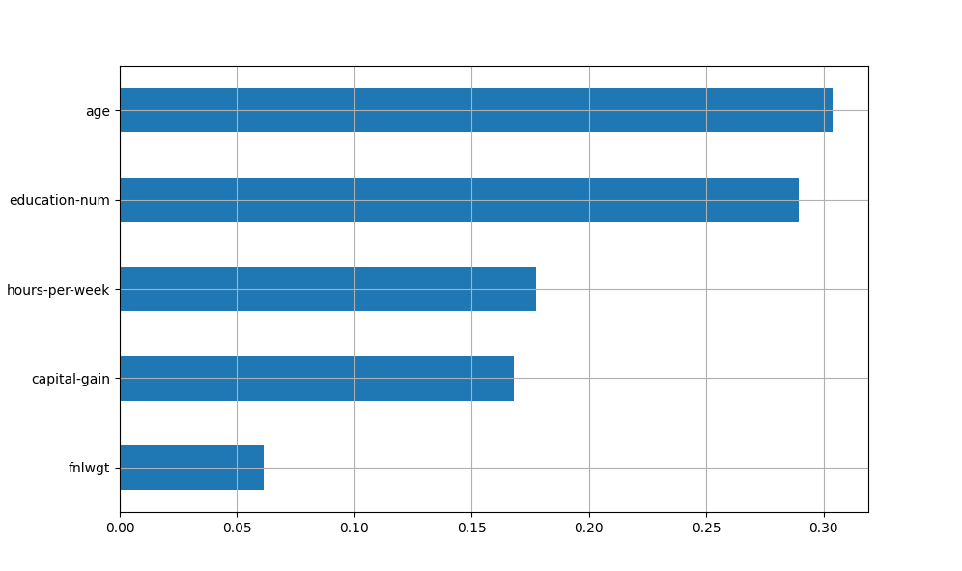

best params = {'rf__max_depth': 12, 'rf__max_features': 0.1, 'selector__param': 5}

train scores = [0.91185327 0.91131239 0.91662501 0.91089456 0.91029048]

mean score = 0.91220 +/- 0.00227

test score = [0.89389047 0.89511106 0.86838463 0.89805705 0.89928409]

mean score = 0.89095 +/- 0.01145